**The Ramifications of Social Media Use on the Wellbeing of Female Adolescents**

***Jessica Nguyen***

*Student ID: 13289576*

*Tutorial 3, Friday 10am*

*Tutor: Thomas Dolmark*

*Submission Date: 08/09/2024*

# **Executive Summary**

The purpose of this report is to justify the consequences of social media use on the overall wellbeing of female adolescents that have been thoroughly established in a wide range of papers that have been researched. This involves but not limited to cyberbullying, risk of privacy information disclosed to wider audience that are not known to female adolescents, and increased levels of depression. Innovation of social media technologies makes an appeal to female adolescents in utilising photo-filtering features that hides their own insecurities of unrealistic beauty standards. A systematic literature review has been conducted using the PRISMA methodology to assist in this research. Diagrams illustrated in this report are stakeholder analysis, empathy map, context map and fishbone diagram to convey the ramifications of social media use.

In these research findings, shows parents, mental health professionals, social media users and companies will be a major contributor to supporting the resolution of this problem statement. The challenge will be to maintain effective strategies in aiding female adolescents in the use of social media within today’s technological society whilst, ensuring the financial growth of social media companies to gain access to global news and topics. It is highly important to beware of the ethical concerns involved where social media platform gain access to many online users’ data through machine learning algorithms.

**Table of Contents**

**Executive Summary 2**

**Introduction 4**

**Discussion 5**

**I. Task 1 – Problem Definition 5**

**II. Task 2 – Stakeholder Understanding 8**

**III. Task 3 – Problem Representation and Understanding 10**

**Conclusion 13**

**Appendices 14**

**Academic References 15**

# **Introduction**

Adolescence is a time for self-exploration, discovering their own identity, plus a developmental stage across to adulthood life. From the transition of childhood to teenagers, their naivety and hoping to find more excitement and adventures during their pre-adulthood journey in exposure to many vulnerabilities. As the Internet expands, young adolescents have been drawn to the allure of social media technology providing a new way to simply connect with people online and explore the realms of the Internet. Throughout this in-depth study, there have been various discussions on the side effects of social media, taking a toll on the wellbeing of many adolescents over the last two decades (Rossi & Barcelos, 2014). With the advancement of social media platforms over the recent years, it has also been more creative and innovative than ever such as Instagram and TikTok. These platforms have been integrated with various features such as photo-filtering tools and gaming spaces, captivating the attention of many young teenagers today. As much as social media can bring fortune in collaborative activities with close ones such as friends and family, it can also bring many negative factors. Through a closer lens, female adolescents have been a bigger subject in terms of associating with social media side effects and studies have demonstrated higher numbers compared to male adolescents. Arguably, there has been no appropriate answer to resolving it, but with distinctive suggestions in aiding other field experts in its solution, hence it is worth the investment for this research.

# **Discussion**

## **Task 1 – Problem Definition**

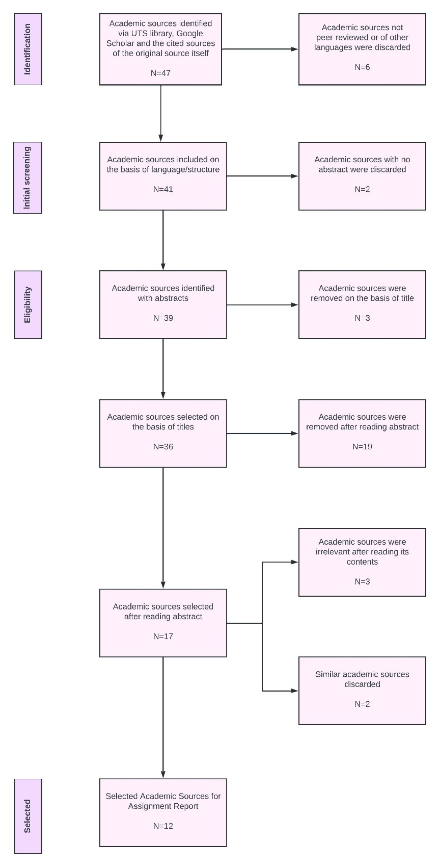

Figure 1. PRISMA diagram on articles researched for problem statement

Adolescents have been inclined to using social media as a means of finding reassurance and support to their real-life problems (Boer et al., 2021). Female adolescents, specifically have been using social media as a way to connect with their friends on the absence of in-person meetings via online chats, performing other digital, collaborative activities, online shopping and even a mode to express a different personality from their usual reality (REF). It also serves as a platform to access a wide range of global topics such as social media influencers, celebrities and even beauty trends. Whilst this may portray the positive characteristics of utilising social media, this begs the question that many female adolescents are captivating with these online platforms for an extensive period of time, leading to a form of addiction.

Additionally, the constant exposure to social media manipulates the minds of female adolescents, causing major health concerns. Female adolescents are vulnerable to online pressures, which intensifies the negative impacts on their overall mental and physical wellbeing. Boer et al. (2021) has established the fact that young women have been classified with increased depressive symptoms, online comparisons, facing cyberbullying and an overall decrease to life satisfaction compared to young men. It is also reported that adolescents of 9th or 10th grade in preparation for the workforce have faced these issues. This is equivalent to adolescents aged 14-16 years of age who are just a few years away from reaching adulthood, meaning prolonged, unhealthy social media habits can be challenging to change, affecting their lives for years to come. The authors also stated results in their research, showing teenager girls have a stronger inclination to making self-comparative judgements based on the social media content presented to them. This further exemplifies the notion of “sexualisation” of females used by Papageorgiou et al. (2022).

Sexualisation refers to the beauty standard, that prioritises sultriness in women, particularly on young girls, as a measure of attractiveness (Papageorgiou et al., 2022). This notion suggests that social media has influenced the minds of young women to perceive beauty in a specific viewpoint, showing the companies’ purpose in product marketing and promoting brands for financial profit. Female adolescents, still developing the ability of making their own decisions, especially their personal beliefs about beauty would be vulnerable to these influences. It is also conveyed in this article that the impact of sexualized images presented has brought young women into increased levels of depressions and the problematic pursuit of a “positive body image”. This pursuit can lead to further complications, such as undertaking cosmetic surgeries to achieve an ideal body image, which not only poses financial burden but also carries serious health risks and even fatalities should the surgeries be unsuccessful.

The rise of social media addiction and health concerns from its uses is primarily due to the investment of creating innovative social media technologies. Photo-filtering tools integrated in many social media platforms has attracted many female adolescents, allowing them to mask insecurities about their appearances exacerbated from these platforms. Rosen et al. (2014) has illustrated the connections of increased screen time leads to increased obesity in adolescents. The authors explained teenagers aged 13-18 years have the largest consumption amount of unhealthy food and beverages. On the contrary, this creates an opposing effect on the notion of pursuit of a “positive body image”. In reference to social media addiction, social media companies enhancing these platforms with the abundance of engaging features causes these female adolescents to idle daily.

The advancement of social media technologies does not focus on the consequences of privacy invasion of personal information being shared amongst various users within the social media network. These video-sharing platforms are simply thought of by teenagers as their playground of providing exciting content related to trends and interests, as there is inadequate knowledge of the risk posed to disclosing personal information (Kang et al., 2021). This may decrease the overall wellbeing of female adolescents in the sense that sharing private information online, can expose to harmful situations such as strangers viewing their content and start relationships with strangers without ever encountering, potentially attracting scammers and other online users can misuse this information further.

Laholt et al. (2019) has conveyed the ethical challenges involved when adolescents are faced in critically high-stake situations. The authors mentioned that many public health nurses face difficulties in interpreting the visual cues displayed when reading social media communication. Some adolescents who seek attention to adults utilise visual images that may appear distressing, however many public health nurses find it challenging to determine whether the situation requires immediate assistance. Also, Poleac et al. (2024) discussed that social media algorithms gather and analyse the users’ data spent on these platforms to personalise feed content. This article by Poleac et al. (2024) presented the idea of exploiting the psychological element of the “Fear of Missing Out” on trends and content from users, especially female adolescents, encouraging them to stay immersed in social media.

Measurement Constraints

* In today’s technological society, brand promotions on social media are vital to business growth, failing to incorporate them will disrupt the flow of gaining profit.
* Sudden cyberattacks are an inescapable risk when accessing social media.
* Some parents may lack technological knowledge required to effectively teach their teenagers to minimise the risk of using social media.
* The quality of social media interaction with various users, for example, female adolescents messaging friends can nurture a positive relationship, however with online strangers can bring low self-esteem and depression.

Assumptions

* The parents of these teenagers as well as mental health professionals are not meant to block all uses of social media as it is inevitable to avoid technology in this modern age. However, to devise strategies or healthy habits to live with social media technologies
* Adolescents are expected to be using technology a part of their daily lives in today’s modern age, otherwise this may come across as uncivilised.
* Mental health professionals are required to be tech-savvy and understand possible visual cues to deal with adolescents’ about healthy social media uses.
* Adolescents must have a basic level of digital literacy, enabling them to navigate social media platforms with sound understanding of controlling privacy settings and content.

Improvement Criteria

* Privacy controls are not consistent in every social media platform. For example, Schenble et al. (2021), analyses several platforms with different minimum age verifications and parental consents where Facebook required a minimum age to register and no parental consent, in contrast to Twitter required no minimum age and no parental consent. Additionally, this article highlights no method to determine if these users are entering true information when registering their age.
* Providing social media education to the necessary parties, such as parents in teaching teenagers effective and balanced practices of using social media.
* Social media algorithms required to be properly managed from an ethical perspective, reducing the absorption of social media use for female adolescents, allowing to freely detach from misconceptions of beauty standards and other elements that may affect their overall wellbeing
* Establishing mental health support systems and resources in social media platforms, allowing to gain immediate access when experiencing low mental states.

## **Task 2 – Stakeholder Understanding**

Table 1. Stakeholder Analysis

|  |  |  |  |  |  |  |
| --- | --- | --- | --- | --- | --- | --- |
| ID | Name | Benefit | Harm | Power | Interest | Strategy |
| SH001 | Female Adolescent | Improves overall mental and physical well-being | Low self-esteem and overall life dissatisfaction due social norms | High | High | Manage Closely |
| SH002 | Family | Ability to guide their teenagers in effective social media practices | Difficulties with maintaining rapid technology changes and under pressures in managing their teenager's social media usage | High | High | Manage Closely |
| SH003 | Teacher | Increased engagement with teenagers as students | Added responsibility in keeping track of students' social media usage and lack of training on social media wellbeing | Low | High | Keep Informed |
| SH004 | Peers | Sharing knowledge of healthy social media habits and increase offline interactions | Loss of friendships, cyberbullying, social comparisons | Low | Low | Monitor |
| SH005 | Social Media Influencer | Build brand awareness for their sponsorship, increase sponsored company profits | Misinformation of unrealistic standards | High | High | Manage Closely |
| SH006 | Online User | Add to the enjoyment of social media content created by female adolescents | Misinformation of unrealistic standards, add-on to social comparisons | High | Low | Keep Satisfied |
| SH007 | Social Media Company | Gain financial profit, building relationships with brands to increase in user engagement | Misinformation of unrealistic standards, reputational damage, legal action against unethical social media platform | High | High | Manage Closely |
| SH008 | Mental Health Professional | Aid teenagers in healthy ways of using social media | Increased demand for support by teenagers, regularly updating social media trends and uses | Low | High | Keep Informed |

Stakeholders with high levels of power play a critical role in the resolution of the problem. Family, teachers and mental health professionals have the ability to assist in guiding effective social media practices, offering improvement of overall health factors. This will support in maintaining control of privacy information shared when using social media explained by Kang et al. (2021) and devise social media detoxes in trends and content faced by female adolescents that is illustrated by Poleac et al. (2024). Female adolescents are classified as a primary stakeholder as they are accountable for their actions in prioritising their overall wellbeing.

Possible solutions that can be developed to strengthen female adolescents’ wellbeing. Firstly, the implementation for a new social media platform that will incorporate all features that teenagers are appealed to from current platforms with customizable privacy controls. This will ensure all users, including the adolescent, parents or any stakeholders of interest are able to track the progression and maintain overall wellbeing of the adolescent themselves. Secondly, a similar end-goal to the first solution, the integration of mental health resources, including a chatbot directly connected with mental health professionals.

## **Task 3 – Problem Representation and Understanding**

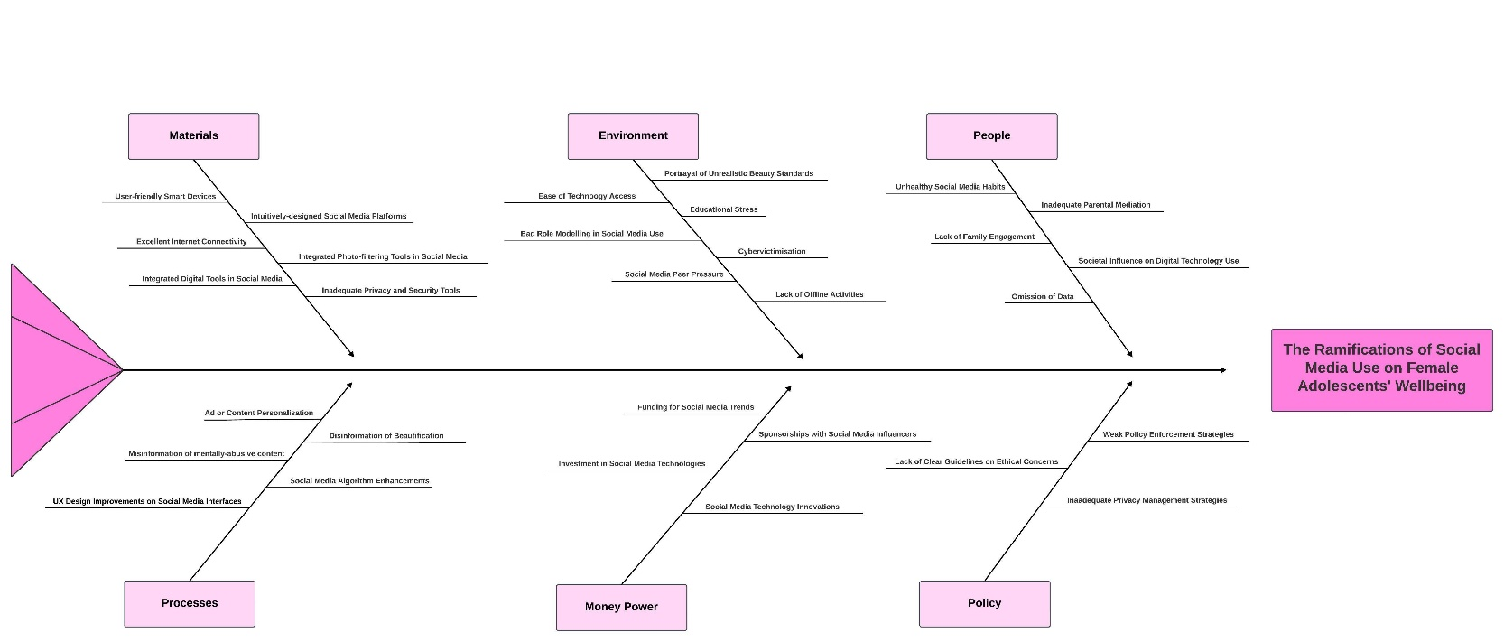

Figure 3. Fishbone Diagram on the Ramifications of Social Media Use on the Wellbeing of Female Adolescents

This figure illustrates the distinctive causes that are associated with the issue of unhealthy social media uses by female adolescents. Firstly, the causes by people represents the lack of parental guidance on effectively teaching their teenagers on social media uses and the consequences involved regarding privacy and security concerns (Kang et al., 2021). It is also complemented with the lack of social media education and the tech-savviness upon parents that determine female adolescents’ wellbeing in facing unrealistic societal expectations, such as beauty (Papageorgiou et al., 2022). Parents do not understand the realms of social media algorithms that target female adolescents’ interests, including the personalisation of ads and content (Rosen et al., 2014). Moreover, social media companies are heavily invested in implementing enhanced social media technologies that feeds on these female adolescents’ absorption in the digital world, thus environmental causes such as more time required spent on offline or leisure activities to stay active outside of social media.

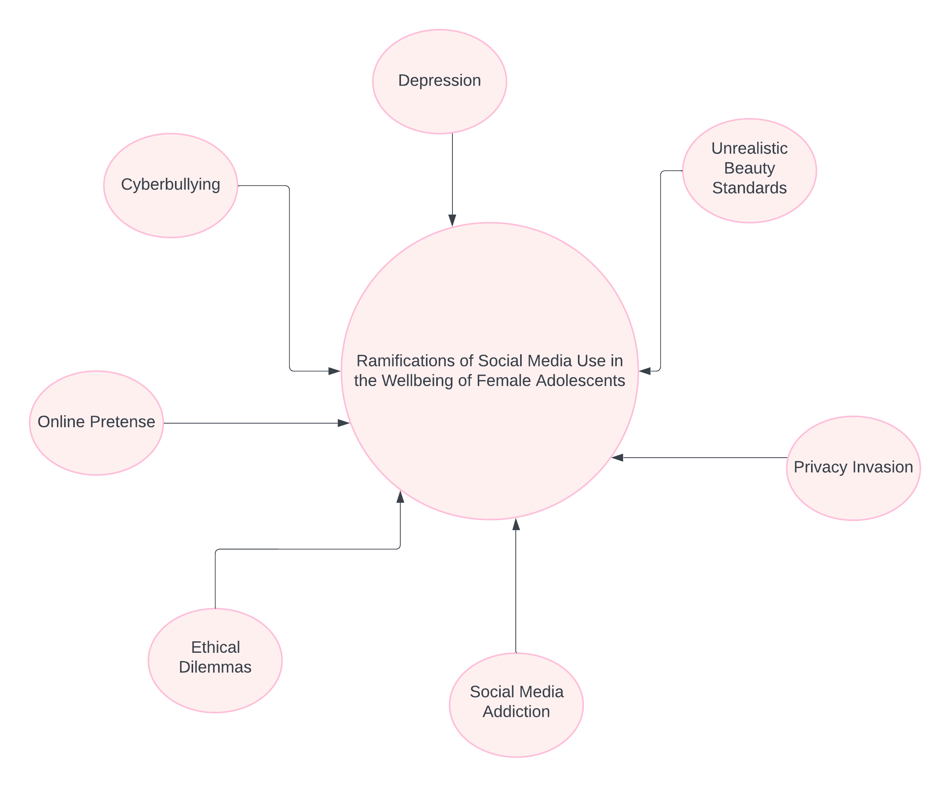

Figure 4. Context Map on the Ramifications of Social Media Use on the Wellbeing of Female Adolescents

This figure demonstrates a holistic view of the major perceptions of negative social media effects against the wellbeing of female adolescents. As covered deeply in Task 1 section, to further add, a common activity done on female adolescents is online pretense where adolescents create various profiles associating each profile as a specific identity. This false identity may provide a positive light in serving as a self-discovery of the adolescent themselves, it can attract predators that may pose risk such as potential scam or safety concerns (Livingstone, S. 2008).

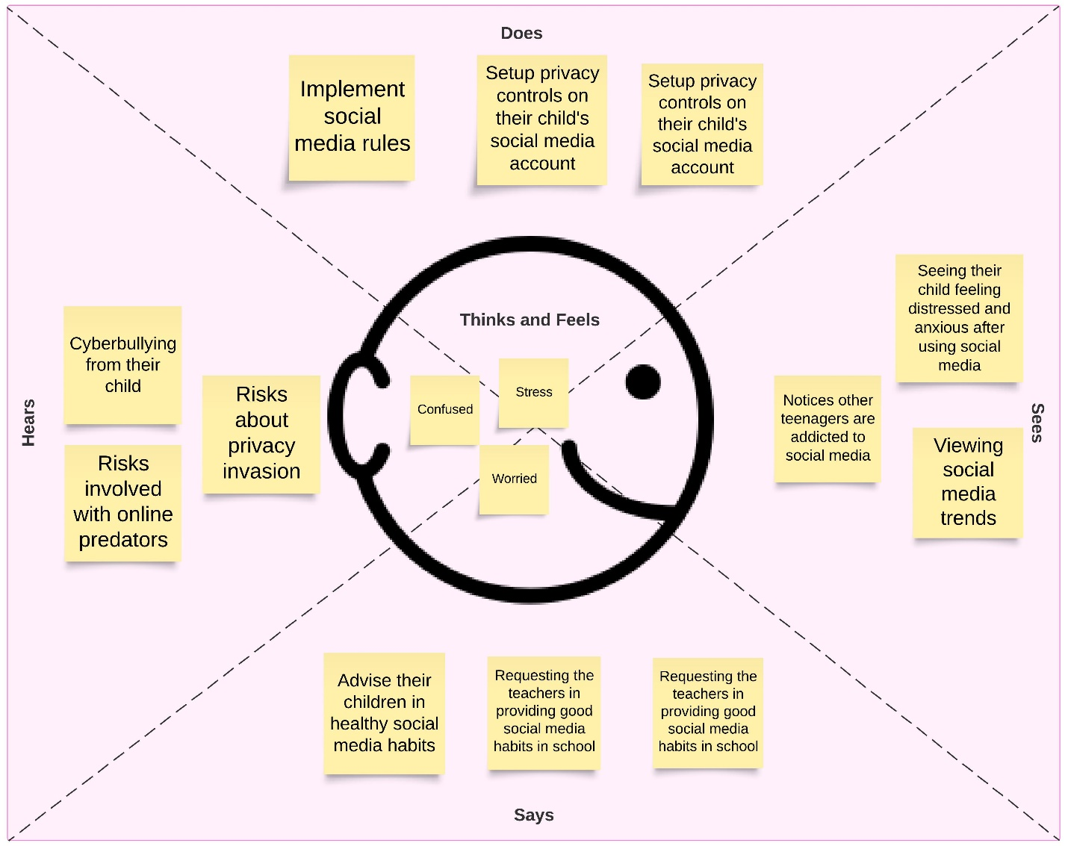

Figure 5. Empathy Map on the Ramifications of Social Media Use on the Wellbeing of Female Adolescents

This empathy map identifies the significant concerns of parents when guiding their own children as teenagers with social media addiction. It outlines the challenges by parents when teenagers are absorbed by unrealistic expectations of society established on social media trends and understand to develop strategies. This can also be used to analyse how parents are able to support their children in effective social media habits whilst not completely blocking their access to it, contributing to their overall life satisfaction.

# **Conclusion**

Overall, social media use can pose a positive light in educating on global topics and maintaining close relationships. As with further research into this problem statement, adolescents, particularly young women have been mentally and physically drained by social media trends of unrealistic beauty standards of a “positive body image” and disclosing personal information to the digital world enabling potential dangers. Many articles have demonstrated that side effects to social media, including on extensive periods of screen time leading to increased obesity in consumption of unhealthy food and beverages and the innovative social media technologies that captivates adolescents. Therefore, it is vital to critically analyse the problem at hand and effectively find approaches in balancing the use of social media.

# **Appendices**

No terms that required further definition, hence this section is left blank.

# **Academic References**

Alberto Vargas Rossi, C., & Hübner Barcelos, R. (2014). Paradoxes and strategies of social media consumption among adolescents. *Young Consumers*, *15*(4), 275-295. https://doi.org/10.1108/yc-10-2013-00408

Boer, M., Stevens, G. W. J. M., Finkenauer, C., de Looze, M. E., & van den Eijnden, R. J. J. M. (2021). Social media use intensity, social media use problems, and mental health among adolescents: Investigating directionality and mediating processes. *Computers in Human Behavior*, 116. https://doi.org/10.1016/j.chb.2020.106645

Kang, H., Shin, W., & Huang, J. (2021). Teens' privacy management on video-sharing social media: the roles of perceived privacy risk and parental mediation. *Internet Research, 32*(1), 312-334. https://doi.org/10.1108/intr-01-2021-0005

Laholt, H., McLeod, K., Guillemin, M., Beddari, E., & Lorem, G. (2019). Ethical challenges experienced by public health nurses related to adolescents’ use of visual technologies. *Nursing ethics*, *26*(6), 1822-1833. https://doi.org/10.1177/0969733018779179

Livingstone, S. (2008). Taking risky opportunities in youthful content creation: teenagers' use of social networking sites for intimacy, privacy and self-expression. *New Media & Society*, *10*(3), 393-411. https://doi.org/10.1177/1461444808089415

Papageorgiou, A., Cross, D., & Fisher, C. (2022). Sexualized Images on Social Media and Adolescent Girls' Mental Health: Qualitative Insights from Parents, School Support Service Staff and Youth Mental Health Service Providers. *Int J Environ Res Public Health*, *20*(1). https://doi.org/10.3390/ijerph20010433

Poleac, G., & Gherguț-Babii, A.-N. (2024). How social media algorithms influence the way users decide – Perspectives of social media users and practitioners. *Technium Social Sciences Journal*, 57, 69-81. https://doi.org/10.47577/tssj.v57i1.10955

Rosen, L. D., Lim, A. F., Felt, J., Carrier, L. M., Cheever, N. A., Lara-Ruiz, J. M., Mendoza, J. S., & Rokkum, J. (2014). Media and technology use predicts ill-being among children, preteens and teenagers independent of the negative health impacts of exercise and eating habits. *Comput Human Behav*, 35, 364-375. https://doi.org/10.1016/j.chb.2014.01.036

Schneble, C. O., Favaretto, M., Elger, B. S., & Shaw, D. M. (2021). Social Media Terms and Conditions and Informed Consent From Children: Ethical Analysis. *JMIR Pediatr Parent*, *4*(2), e22281. https://doi.org/10.2196/22281